Tasks on Analytic Hierarchy Process (choose 1 of 3):

1. The personnel department at C&H has narrowed the search for a prospective employee to three candidates: Steve (S), Jane(J)*.* and Maisa (M) The final selection is based on three criteria: personal interview (I), experience (E). and references (R). The department uses matrix A (given below) to establish the preferences among the three criteria. After interviewing the three candidates and compiling the data regarding their experiences and references, the matrices $A_{I}, A_{E}$ and $A_{R}$ are constructed. Which of the three candidates should be hired? Assess the consistency of the data.

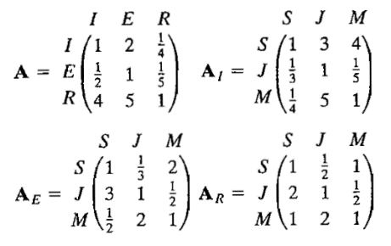

1. Kevin and June Park (K and J) are in the process of buying a new house. Three houses, A. B, and C are available. The Parks have agreed on two criteria for the selection of the house: yard work (V) and proximity to work (W), and have developed the following comparison matrices. Rank the three houses in order of priority, and compute the consistency ratio for each matrix.

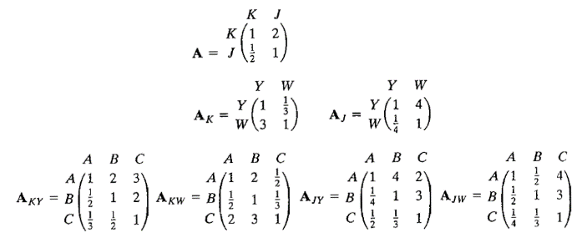

1. A new author sets three criteria for selecting a publisher for his textbook: royalty- percentage (R), marketing (M), and advance payment (A). Two publishers, *H* and *P.* have expressed interest in the book. Using the following comparison matrices, rank the two publishers and assess the consistency of the decision.

